SMALL VESSEL SAFETY MANAGEMENT

“M.V. SAFETY FIRST”
(View as a Pdf)
The Organization, Policies and Procedures described are fictitious, not complete and are as example only for small vessels.

Implementation date_______________ Review date___________________

 |  | 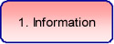
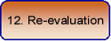 |  | 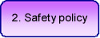 |  | 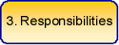
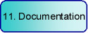 |  | 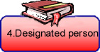 |  | 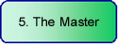
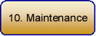 |  |  |  | 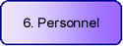
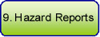 |  | 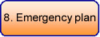 |  | 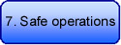

This Safety Management Systems Manual and supporting documents reflect a commitment to providing a safe and healthy workplace and encouraging pollution-free practices, in compliance with current legislation.

All subsequent reference to the Company in this manual applies to the management organisation of the ship named above.

1. Information
Summary of ship & company
Emergency numbers

2. Safety and environmental protection policy.
Safety of personnel (WH&S Policy)
Drug & Alcohol Policy
Protection of the environment

3. Responsibilities and authorities
Manpower structure
Job Descriptions

4. Designated safety persons

Safety Officer (designated person ashore)

5. The Masters responsibility and authority

Master’s Duties

6. Resources and personnel
Staff Qualifications

Staff induction
Training

7 Safe Operations
List of procedures

8. Emergencies
Musters and drills
List of procedures

9. Reports and analysis of non conformities accidents and hazardous occurrences
Policy
First aid
Workers compensation
Rehabilitation policy

10. Maintenance
Schedules

11. Documentation
List of forms

12. Verification review and evaluation
Policy
Audit documentation
Risk management

1. Information

Summary of Ship and Company information:

VESSEL:

Vessel name M.V. Safety First Port of registry ___________________

Permit No. __________________ Survey class __________________

Length ______________Breadth_______________ Max Draft_____________

Tonnage _________________________ Max Capacity ____________________

Propulsion unit_______________________ Generator unit ____________________

COMPANY OPERATIONS:

Company name __________________ Area of operation __________________

Fleet details _______________________________________________________

Address _________________________________________________________

Phone/fax ______________________ Email ___________________________

Manager_________________________ Phone __________________________

Designated person __________________ Phone __________________________

EMERGENCY NUMBERS:

Company (24 hrs) Phone __________________ Radio _______________________

Harbour Authority Phone ________________ Radio ________________________

Fire Brigade _________________________ Police________________________

All subsequent reference to the Company in this manual applies to the management organisation of the ship named above.

2. Safety and environmental protection policy.

The Safety Management objectives of the Company are to:
- provide for safe practices in vessel operation and a safe working environment.
- establish safeguards against all identified risks.
- continuously improve the safety management skills of its personnel.

This will be achieved by:
- ensuring that SMS/WHS procedure is followed and performance is documented.
- establishing workgroup consultative arrangements to identify potential hazards.
- promoting safety motivation by training that addresses regulations and guidelines.

Safety of personnel (WH&S Policy)
The Company provides equal opportunities for its employees regardless of gender, race or disability. The health and safety of all persons employed and visiting the company are of the utmost importance. The promotion and maintenance of systems to maintain a safe and pollution-free operating practices is primarily the responsibility of management in consultation with the designated person (safety officer). The Operational and Emergency procedures in the SMS are developed using risk management strategies and are continually reviewed for currency to ensure safety in the workplace.

The employer has a duty of care to ensure that:
- The workplace is safe and adequately signed
- Equipment is in a safe condition.
- Protective clothing is available.
- The workforce is properly trained.
- A risk analysis and monitoring is taking place.

The employee has a duty of care to ensure that:
- Fellow workers are not placed at risk.
- Safety equipment is used as required.
- Safety equipment and strategies are not abused.

Drug & Alcohol Policy
It is not acceptable for any staff member to be under the influence of alcohol, or non medication drugs during any working shift day or night. Any staff member found under the influence of either alcohol or non medication drugs would not be fit or permitted to work and will be placed on a warning by the Manager. If a second warning has to be placed counselling would be offered for their problem. If this behaviour continued the Manager has the right under the WHS Acts to dismiss the employee to stop any endangerment to passengers or other staff members. In the case of suspected drug/alcohol use the Company will operate random testing with the cooperation and consent of the workforce. Any medication that is prescribed by a doctor is acceptable, but if the medication states that it causes drowsiness or do not drive, it is required that the employee has time off from transport safety work whilst on the medication. It is prohibited to supply passengers with Panadol, Aspirin or any other painkiller related drug at any time.

Protection of the environment
The Operational and Emergency procedures in the SMS are developed using risk management strategies and are continually reviewed for currency to ensure environmental protection.

3. Responsibilities an authorities

Manpower structure:
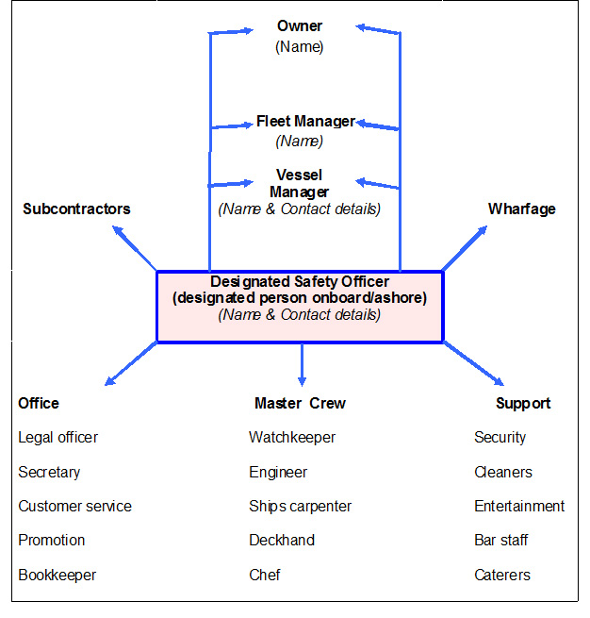
Contractors and Sub-Contractors engaged to perform work on the organisation's premises or locations are required, as part of their contract, to comply with the OHS policies of the Company.
Persons must not:
- Interfere with or misuse WHS equipment or signage.
- Obstruct attempts to prevent risk to the health and safety of a person at work.
- Refuse a reasonable request to assist in giving aid.
- Disrupt a workplace by creating health or safety fears.

List of Job descriptions:

The size of the Company is such that some employees are required to perform several duties. In this case the employees have been given multiple job descriptions as is appropriate to their multiple duties.

See full list
Job description Bar Person
Job description Bookkeeper
Job description Caterer
Job description Cleaner
Job description Chef
Job description Contractors
Job description Customer service
Job description Deckhand
Job description Designated person
Job description Engineer
Job description Entertainer
Job description Fleet Manager
Job description Legal officer
Job description Manager
Job description Master
Job description Promotions officer
Job description Safety officer
Job description Secretary
Job description Security officer
Job description Ships Carpenter
Job description Trainee
Job description Watchkeeper
Job description Wharf hands

4. Designated person (Safety Officer)

The Company has appointed a Designated Person/s ashore with the responsibility for monitoring the safe operation of the vessel. He/she has direct access to the top management of the Company and sufficient resources and authority to carry out his/her duties.

Designated Person/s ashore name ___________________________________________

Designated Person/s ashore contact detail ___________________________________________

Duties:

Safety Officer (Designated Person Ashore)
The position is the company’s Designated Person. He or she reports to the highest person in the organization on matters which require the attention of the highest level of management.

- monitoring the SMS and reporting when remediation or change is needed.
- monitoring the safety and pollution prevention aspects of each vessel in the fleet;
- ensuring that adequate resources applied when required;
- training and appointing internal auditors;
- liaising with external auditors to schedule annual audits;
- taking into consideration all mandatory regulations, codes and guidelines.

5. Master’s responsibility and authority.

The master has complete authority and responsibility for taking all necessary actions in the interests of safety, pollution prevention and the efficient operation of the vessel.

He/she may deviate from documented procedures if human life, property or the environments are at risk. He/she may ask the Company for help if he/she deems it necessary. In all matters, which affect or may affect safety of life, property or the environment, the Master shall report directly to the Designated Person.

Duties:
The Master is responsible for:
- implementing the safety and environmental-policy;
- motivating the crew in carrying out the Company’s safety and environmental-protection policy;
- reviewing safety and pollution prevention activities and reporting defects to the Company;
- issuing orders in a clear and concise manner;
- ensuring that matters relating to safe operations and pollution prevention risk are carried out as required;
- reporting non-conformities, accidents and hazardous occurrences to the office;
- assigning SMS related duties and responsibilities to all onboard personnel;
- liaising with the Designated Person in relation to onboard audits;
- evaluating and reviewing the SMS on board the vessel and reporting any deficiencies to the office.
- ensuring that data and records relevant to the SMS are available

6. Resources and personnel

Staff Qualifications
The designated person will maintain a staff matrix ensure that the qualification and experience of its employees will meet the current legal requirements and are adequate for the safe operations of the company. See the staff qualifications matrix.

Staff induction
The Company gives a new master reasonable opportunity to familiarize with the vessel and SMS, and gives them support to enable them to perform their duties safely. Each vessel will be manned, as a minimum, in accordance with survey requirements. The masters and crew will be adequately experienced and qualified. The Company ensures through the policy, checklists and job descriptions that personnel are aware of their individual responsibility for safe vessel operation and overall protection of the environment. Essential instructions described in the Staff induction plan of the SMS are prerequisites for new crew members on work commencement and are provided to joining crew before sailing. The Company continually identifies training requirements for shore and seagoing personnel in support of the SMS. If a gap in training relating to safety and/or environmental-protection is detected in an employee, he/she will not be assigned any task where the gap in training will put life, property or the marine environment at risk until he/she has received appropriate training.

Training

In the implementation of an effective control plan, the motivation and cooperation of the staff is essential. The Company recognises that while the necessity to monitor and document places a burden on staff, the encouragement of safe attitudes is the foundation of safe practice.

Safe attitudes are encouraged within the Company by both the informal participation in safety meetings and briefings, formal participation in musters and drills, review of operational & emergency plans (control) checklists and currency in training. The examples from safety talks and case studies are discussed to promote safety awareness.

7. Safe Operational Procedures

Operational Procedures | Task analysis | The plan | Review due
Initial entry |  | View | 01/01/08
Anchoring |  | View | 01/01/08
Bar crossing |  | View | 01/01/08
Bar and food service hygiene |  | View | 01/01/06
Bilge pumping | View | View | 01/01/08
Boarding /disembarkation |  | View | 01/01/08
Boom netting |  | View | 01/01/08
Bridge management |  | View | 01/01/08
Cargo loading & stowage |  | View | 01/01/08
Cleaning |  | View | 01/01/08
Confined spaces |  | View | 01/01/08
Contractor provided services |  | View | 01/01/08
Crew briefing | View | View | 01/01/08
Diving operations |  |  | 01/01/08
Engineering management |  | View | 01/01/08
Garbage | View | View | 01/01/08
Maintenance | View | View | 01/01/08
Manual handling | View | View | 01/01/08
Oils | View | View | 01/01/08
Passenger briefing | View | View | 01/01/08
Refuelling | View | View | 01/01/08
Sullage (Sewerage) | View | View | 01/01/08
Slipping |  | View | 01/01/08
Shut down |  | View | 01/01/08
Staff induction |  | View | 01/01/08
Survey |  | View | 01/01/08
Towing |  | View | 01/01/08
Print out a blank Risk Assessment Matrix Document

8. Emergency Procedures

Musters and drills:
Drills will be as realistic as possible and include both testing and operation of emergency equipment. Vessels with more than four crew will perform musters and drills schedules:

Emergency Drills at monthly intervals - includes emergency steering.

Abandon ship at two monthly intervals - includes use of lifeboats.
Fire drills at two/three monthly intervals - includes use of fire hoses.
Collision drills at two/three monthly intervals - includes inflooding controls.

Masters of vessels of less than four crew are not required to perform scheduled drills, but will ensure that their crews are practiced in the emergency procedures. Drills are recorded in the log.

List of emergency procedures

Emergency Procedure | Task analysis | The  Plan | Review due
Abandon ship | View | View | 01/10/08
Casualty | View | View | 01/01/08
Collision | View | View | 01/01/08
Excessive list | View | View | 01/01/08
Fire | View | View | 01/01/08
Fixed fire fighting | View | View | 01/01/08
Founder | View | View | 01/01/08
Grounding | View | View | 01/01/08
Incident |  | View | 01/01/08
Incident office | View | View | 01/01/08
Injury/illness |  | View | 01/01/08
Machinery failure | View | View | 01/01/08
Man overboard | View | View | 01/01/08
Rigging failure |  | View | 01/01/08
Robbery/armed hold up |  | View | 01/01/08
Spillage | View | View | 01/01/08
Steering failure | View | View | 01/01/08
Structural failure | View | View | 01/01/08
Towing | View | View | 01/01/08
Welding (emerg. repair) |  | View | 01/01/08
Print out a blank Risk Assessment Matrix Document

9. Reports and analysis of non conformities accidents and hazardous occurrences.

All non-conformities, accidents and hazardous occurrences on board are reported through the Master to the Designated person (Safety officer). The Designated person reviews the reports and causes them to be investigated and analyzed with the objective of improving safety and pollution prevention. The Designated person agrees with the Master or appropriate supervisor on the appropriate corrective action and time frame for rectifying the defect. When the agreed time limit has been reached or corrective action taken, whichever occurs earlier, the Designated person checks the corrective action for effectiveness. If the corrective action is satisfactory and further action is not required, the Designated person closes the investigation. If the corrective action is not satisfactory, or if preventive action is required, the investigation is maintained until such time as no further action is required. The results of analyses may be used to:

- initiate general corrective action to other vessels
- initiate amendments to the SMS to prevent recurrence

The Master is responsible for reviewing the vessel’s SMS and notifying the Designated person of any discrepancies or deficiencies which may affect safety or anti-pollution capability

First aid Immediate response - exposure to hazardous substances:

Eyes - Hold eyes open and flood with cold water for 15 minutes. Seek Medical Attention immediately.

Skin Contact-Remove contaminated clothing and wash affected area thoroughly under cold running water.

Inhalation-Remove to fresh air, if person is not breathing, ensure airways are clear and commence cardiopulmonary resuscitation. Seek Medical Attention immediately.

Ingestion and Corrosives-Consult the label and Material Safety Data Sheet; follow health hazard and first aid directions. Seek Medical Attention immediately. DO NOT induce vomiting. Give a glass of water and Seek Medical Attention Immediately.

Spillages-Avoid secondary accidents, if product is flammable extinguish all fire sources.
Consult Material Safety Data Sheets (MSDS) for procedure.
View Queensland Health (Internet links) View NSW Health (Internet links)

Sydney Poisons Emergency Information Centre 131126

Workers Compensation

Employers Responsibilities
Employers have a wide range of responsibilities under the occupational health and safety and workers compensation legislation. Some of the main obligations include:
- Provide a safe and healthy workplace for employees and others at the workplace
- Establish a consultative mechanism to enable employees to contribute to the making of decisions affecting their health, safety and welfare at work
- Notify WorkCover within 7 days if an injury at your workplace has resulted in a significant injury or fatality.
- Have a workers compensation insurance policy covering all employees.
- Display a summary of the Workplace Injury Management and Workers Compensation Act in the workplace
- Have a return to work program consistent with their insurer's Injury Management Program
- Provide suitable duties, where reasonably practicable to do so
- Comply with an Injury Management Plan written for a worker
- Not to dismiss a person wholly or mainly because of work related injury within 6 months after the worker becomes unfit for employment

After terminating an injured worker due to inability to perform their duties employers must notify the replacement worker of the injured worker's right to apply for reinstatement within 2 years if they become fit for employment within that time.

Employees Responsibilities

- Notify the employer of injury as soon as possible
- Provide specified information to the insurer in relation to the claim
- Authorise the nominated treating doctor to provide information to develop an Injury Management Plan
- Make all reasonable efforts to return to work
- Comply with the provisions of the insurer's Injury Management Plan
- Notify the employer of any change in their employment status or earnings
- Attend medical appointments as directed by the employer
- Not to make a statement in a notice of injury, in a claim or in a medical certificate or other document that relate to a claim or when furnishing information in relation to a claim.

Employees Rights
- Their right of choice of a nominated treating doctor and rehabilitation provider
- Access to interpreter services where appropriate
- Their right not to be dismissed with 6 months of an injury, solely or principally due to that injury
- Their participation in a return to work program, which will not of itself, prejudice an employee in either job security, promotion or workers compensation benefits
- Their non-participation in an injury management plan or return to work program which may result in suspension or reduction of weekly benefits.
- Their nomination of a treating doctor who is willing to participate in the development of, and in the arrangements under an Injury Management Plan.

Rehabilitation Policy

Employers Responsibilities
The Company has a wide range of responsibilities under the Occupational Health and Safety and Workers Compensation legislation. Part of those responsibilities is to have a rehabilitation program for injured staff. These following points are all related to the rehabilitation process.

Injury Management Program
- Determine who is to be involved in the process.
- Completing the employer report of injury form.
- Submitting the insurer the workers claim form, WorkCover medical certificate, witness report and wage details.
- Contacting the treating doctor to discuss return to work.
- Identifying suitable duties.
- Writing up the Return to Work Plan and negotiating with the worker and doctor.
- Monitoring the return to work and up-grading duties as required.
- Engaging or liaising with the Rehabilitation Provider.
- Maintaining contact with the Insurer and following up payments.
- Reviewing the progress of the claim to a successful conclusion.

Determine the Procedures and Document
- An injury reporting procedure (to include notification of significant injuries to insurer within 48 hours and to WorkCover within 7 days and links workers compensation claims forms to the procedure where necessary).
- A return to work program (specify your commitment to injury management and is used to explain the program to all workers).
- An Injury Management Plan (will be developed by the insurer).
- A Return to Work Plan (employers are to develop for individual injured workers to help you plan and manage the early return to work of workers on suitable duties.

Return to Work Procedures
The following general procedures have been established by the Company to ensure the safe and speedy return to work of injured employees.

1. When an Injury Occurs:
- All injuries must be notified and reported on immediately in accordance with the company's Workers Compensation Procedures.
- The importance of the legal requirements to notify company's workers compensation insurers of the injury within the stated time frames.
- The Manager will be responsible for coordinating all efforts aimed at assisting the injured worker recover and return to work as quickly and as safely as possible.
- For all lost time injuries, office Administrator will contact the injured employee within 24 hours of the injured being reported to ensure: that appropriate medical attention is received, that the process of lodging a workers compensation claim is explained and to prepare the injured employee for a safe and timely return to work consistent with medical advice.

2. Nominating a Treating Doctor:
- Injured employee MUST nominate a treating doctor

3. Involving a Rehabilitation Provider:
- When it becomes evident that an injured employee is not likely to resume their pre-injury duties or cannot do so with out changes to the workplace or the work practices, the Manager will consult their Company's workers compensation insurers, and the workers treating doctor to discuss the need to involve an accredited Rehabilitation Provider to assist develop and monitor the Return to Work Plan.

4. Finding and Providing Suitable Duties:
- The Manager in consultation with the treating doctor will ensure that individual return to work strategies is developed for each injured worker.

- This will include the provision of suitable duties for those workers who are partially incapacitated and therefore need to be offered suitable duties as part of their rehabilitation program.

- The company undertakes to ensure that the duties offered to injured employees as part of their Return to Work program will always be meaningful, productive, a safe match with the client's physical and psychological capabilities and consistent with medical advice

5. Consultation:
- The Office Administrator will consult with injured worker, doctor, insurer and co-worker regarding the implementation of any arrangements for the return to work of injured employees of the company.

6. Disputes:
- The Office Administrator will attempt to resolve any disputes by consulting with employees, the Rehabilitation Provider and the treating doctor. If the dispute cannot be resolved the insurer will be contacted for advice.

Endorsement:
These policies and procedures are effective as of the 1 Jan 2005 and may be reviewed and amended by the agreement of the undersigned or their representatives:

Signed: Signed:

Employer's Representative Employee's Representative

Date: ..................................................... Date: .................................................

View the Return to work plan documentation.

View the Return to work plan progress review documentation.

10. Maintenance

The company maintains procedures and instructions to ensure that each vessel and all machinery and equipment on board are maintained in accordance with relevant rules and regulations, company’s requirements and manufacturer’s instructions Systems identified for programmed testing include:

Schedules:

Daily:
Cleaning
Deck rounds
Engineering pre-departures
Navigational, lights and fire watch
View pre-departure checklist

Weekly:
Inspection of galley and bar hygiene
Inspection of rope and wire
View maintenance checklist

Monthly:
Inspection of emergency steering, survival equipment, fire fighting equipment
Engine service

Three monthly:
Survey of emergency steering, survival equipment, fire fighting equipment and pumps
Confined spaces, cofferdams, stores
LPG safety
Vermin inspection and control
Watertight alarms

Six monthly:
Bilge system
Certification of wire rope and chain
Electrical safety
Portable fire extinguishers /Fixed fire fighting system
Steering

Annual:

For full list see:
View record of survey schedule

The list is not exhaustive and vessel’s personnel are encouraged to suggest to the Designated Person items that they feel should be included in the list.

11. Documentation

Changes of currency and review are dated in each document. All SMS plans (control checklists) are kept onboard the vessel and ashore. All records are kept for five years.

Ashore in the office, the Designated Person is responsible for issuing and audit of controlled documents of vessels. Obsolete documents are promptly removed to file. The Designated Person reviews all amendments to the SMS prior to issue.

Onboard vessel, the Master is responsible for the issue of controlled documents available at each relevant work station. He/She is also responsible for ensuring that obsolete records are removed to avoid inadvertent use.

Sample List of forms:

Application forms list (Maritime Authorities)

Control checklists

More Forms

12. Verification review and evaluation

The Designated person/Safety Officer has the responsibility for monitoring the safe operations by:
- monitoring the SMS and reporting the position if remedial action or changes are needed.
- monitoring the safety and pollution prevention aspects of each vessel in the fleet;
- ensuring that adequate resources and shore- based support are applied, as required;
- appointing internal auditors; and train internal auditors;
- drawing up the year’s audit schedule;
- liaising with external auditors for office and vessel audits.
- taking into consideration all mandatory and relevant rules, regulations, codes and guidelines and standards.

Audit checklists
The Designated person/Safety Officer will monitor the appropriateness, effectiveness and currency of the implemented control plans by the scheduled examination of:

- The audit of incident, accident and other ships safety reportage documentation.
- The audit of the vessel’s operational & emergency checklists.
- The audit of staff in-service training.
- The audit of the staff qualifications and certification validity.
- The audit of the Vessel’s Record book and drills and musters.
- The audit of an independent surveyor. (safe workplace)
- Audit of first aid kit contents.
- Audit of personnel protective equipment.

Staff training, inclusion in safety planning and the valuing of safe attitudes are encouraged in order to develop safe procedures in the company’s operations. Sample Audit documentation:

Risk management:
It is the policy of the Company to maintain this system to ensure occupational health and safety hazards are identified, recorded, investigated, analysed, corrected (eliminated or controlled) and verified. A review and evaluation process promotes hazard reduction by:

1. Identification of all potential hazards.
2. Assessment of the risk posed by each hazard.
3. Elimination or development of a control plan (control checklist).
4. Re-evaluation of the records in order that the plan may be improved.

1. Hazard Identification:
Hazards to persons may be categorized as:

Gravitational
Striking hazards
Electrical hazards

Chemical
Work environment
Manual handling
Other (operationally specific

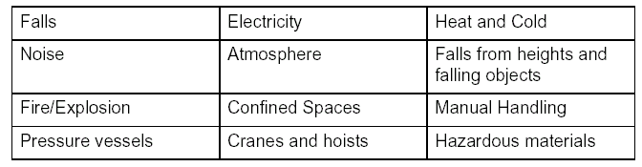

Hazards to vessels can be Navigational, Structural or Environmental.The identification of hazards to persons is carried out by the designated person by methods such as listed below:
- Systematic walk around survey.
- Task analysis
- Consultation and interview of the workforce /staff meetings.
- Safety advice/complaints from customers.
- The compilation and review of Material safety data sheets.
- AMSA Marine Notices and WH&S advisory publications. (Internet links)
- The audit of incident, accident and other ships safety reportage documentation.
- The audit of National WH&S statistics and safety alerts. (Internet links)
- Independent audit.
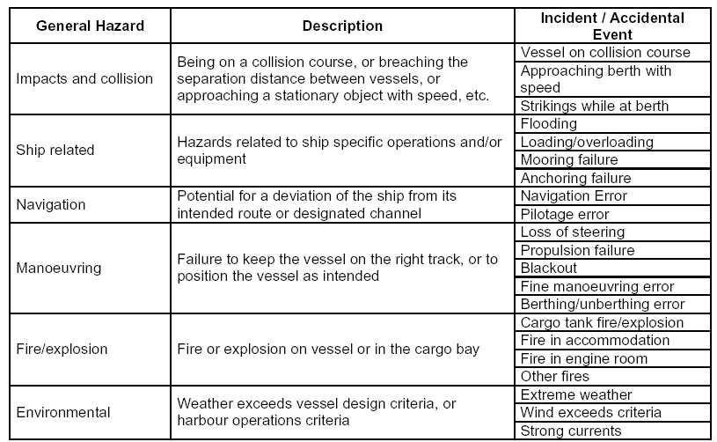

2. Risk assessment:
Risk Level = Consequence X Exposure X Probability
(outcome severity) (frequency/duration) (likelihood)

The level of risk from a hazard will determine the scale of control measures required.
In order to optimize the resources of the Company in developing the most effective control plan, the identified hazards are risk assessed either formally or informally.

To determine low risk activities, an informal assessment considers risk level by discussion and consultation. Appropriate control measures (as described below) are adopted and an agreed safe workplace practice is implemented. The designated person monitors the effectiveness of the implemented plan.

To determine high risk activities, a formal assessment is only used where considerable recourses, expense or complexity in implementing the control plan are required. Such assessments will determine the risk level by the matrix shown below and/or other supportive documentation researched by the designated person.

5
5
4
3
3
Very Unlikely
4
4
4
3
2
Unlikely
4
4
3
2
1
Likely
3
3
2
1
1
Very
Likely
Negligible
Minor
Major
Critical
Fatal

Appropriate control measures (as described below) are adopted and an agreed safe workplace practice is implemented. The designated person includes the control plan on the risk assessment audit and monitors the effectiveness of the implemented plan.

Risk assessment of complex /inter-related hazards may require the determination of the risk level by a global matrix, other supportive documentation (researched by the designated person) and the negotiation with officers of the company and Government enforcement agencies.

3. Control plan:
In developing a control plan the Company recognises that elimination of the hazard is the best of all results. Where this is not possible a number of alternative actions may be considered.

Engineering controls-
Get the design right in the first place
Redesign
Removal at source
Substitution

Administrative controls-
Checklists
Entry permits
Segregation / Isolation
Signage

Record keeping

Work practice controls-
Safe work practices
Passenger and crew briefing

Personal protective equipment and rescue equipment
Drill and musters

Training and staff development

4. Monitor, review and evaluation
Re-evaluation of the records in order that the plan may be improved.

Ranger Hope © 2005

